**Homewares & Appliances**

**Alfresco Kitchens NZ**

Turn your backyard into an entertainer’s dream

alfrescooutdoorkitchens.co.nz

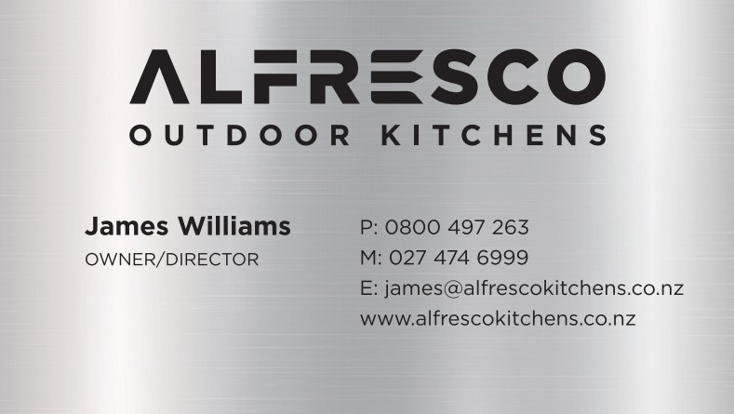



Heathcotes

Appliance Retail (Instore & online)

[sales@heathcotes.co.nz](mailto:sales@heathcotes.co.nz)

Hamilton: 07 839 5443

The Base: 849 4005

https://www.heathcotes.co.nz/